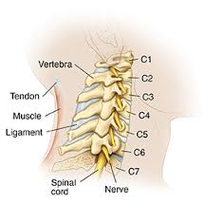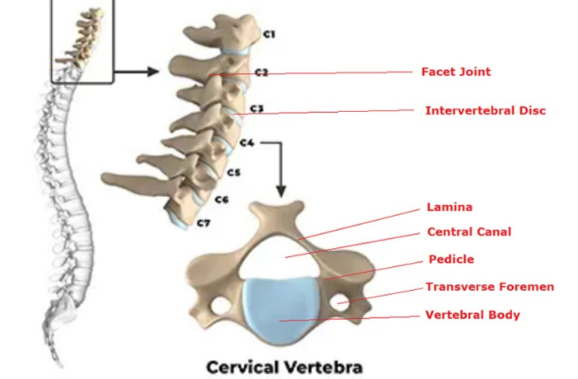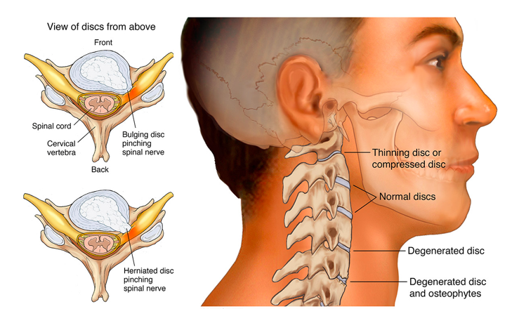

1. **Straightening of cervical spine - Possibly due to Spasm:**

Straightening of Cervical Spine: A Possible Link to Muscle Spasm

Yes, it's quite possible that a straightening of your cervical spine is caused by muscle spasm.

Understanding the Cervical Spine:

The cervical spine is the upper part of your spine that supports your head. It has a natural curve called lordosis. This curve helps distribute weight, absorb shock, and allow for flexibility.

The Role of Muscle Spasm:

When muscles in your neck spasm, they contract involuntarily and tighten. This can pull on the vertebrae in your cervical spine, reducing the natural curve. Over time, this constant tension can lead to a straightening or even reversal of the cervical lordosis.

Symptoms and Causes:

Symptoms of a straightened cervical spine due to muscle spasm often include:

Neck pain and stiffness

Headaches

Shoulder pain

Limited neck movement

Other potential causes of a straightened cervical spine include:

Poor posture

Degenerative disc disease

Osteoporosis

Spinal injuries

Treatment Options

If you're experiencing these symptoms, it's essential to consult a healthcare professional for an accurate diagnosis. Treatment options might include:

Pain relief: Over-the-counter pain relievers, muscle relaxants, or in some cases, stronger pain medications.

Physical therapy: Exercises to strengthen neck muscles, improve flexibility, and correct posture.

Heat or cold therapy: Applying heat or cold packs to the neck can help reduce pain and muscle tension.

Spinal manipulation: Chiropractic or osteopathic adjustments may help restore normal spinal alignment.

Focus on:

Strengthening neck muscles: To support the cervical spine.

Improving flexibility: To increase range of motion.

Correcting posture: To maintain the natural curve of the neck.

Exercise Examples:

1. Chin Tuck:

Sit or stand upright with good posture.

Gently tuck your chin in, as if creating a double chin, without tilting your head forward or backward.

Hold for 5 seconds, then relax.

Repeat 10 times.

2. Neck Retraction:

Sit or stand tall.

Imagine drawing your head straight back, as if someone is gently pulling it backward.

Hold for 5 seconds, then relax.

Repeat 10 times.

3. Neck Rotation:

Gently rotate your head to the right, then to the left.

Hold each position for 5 seconds.

Repeat 5 times in each direction.

4. Neck Flexion and Extension:

Slowly nod your head up and down, as if saying "yes."

Hold each position for 5 seconds.

Repeat 10 times.

5. Shoulder Rolls:

Relax your shoulders and gently roll them forward, backward, and up and down.

This helps release tension in the neck and upper back.

6. Cat-Cow Pose (Yoga):

Get on your hands and knees.

As you inhale, arch your back like a cat, dropping your head.

As you exhale, round your back like a cow, lifting your head.

7. Child's Pose (Yoga):

Kneel on the floor with your big toes touching.

Sit back on your heels and fold forward, resting your forehead on the ground.

This pose helps stretch the neck and back muscles.

Additional Tips:

Maintain good posture throughout the day.

Avoid sleeping on your stomach.

Take regular breaks from activities that involve looking down, such as using a computer or phone.

Apply heat or cold therapy to the neck for pain relief.

Physical Therapy

Physical therapy focuses on improving mobility, strength, and function. For a straightened cervical spine, it often involves:

Manual therapy: Techniques like massage, mobilization, and manipulation to relieve muscle tension and improve joint mobility.

Therapeutic exercises: Targeted exercises to strengthen neck muscles, improve flexibility, and correct posture.

Posture education: Learning proper posture and how to maintain it throughout the day.

Modalities: Use of heat, cold, or ultrasound to reduce pain and inflammation.

Chiropractic Care

Chiropractors focus on the alignment of the spine and the body's musculoskeletal system. For a straightened cervical spine, they might use:

Spinal adjustments: Gentle manipulation of the spine to restore alignment and improve joint function.

Soft tissue therapy: Massage and other techniques to relax muscles and reduce tension.

Posture correction: Advice on improving posture to alleviate strain on the cervical spine.

It's important to note that both physical therapy and chiropractic care can be beneficial, and in some cases, a combined approach might be recommended.

Choosing the right approach depends on the underlying cause of the straightened cervical spine and the severity of your symptoms.

Other Treatment Options

While physical therapy and chiropractic care are often the first lines of defense for a straightened cervical spine, other options might be considered depending on the underlying cause and severity of your condition:

Medications: In some cases, pain relievers or muscle relaxants might be prescribed for short-term relief.

Injections: Corticosteroid injections can help reduce inflammation in the neck.

Surgery: In rare cases of severe spinal instability or nerve compression, surgery might be necessary.

Choosing a Healthcare Provider

Selecting the right healthcare provider is crucial for effective treatment. Consider the following:

Qualifications and experience: Ensure the provider has the necessary training and experience in treating neck pain and spinal conditions.

Recommendations: Ask friends, family, or your primary care physician for recommendations.

Insurance coverage: Check with your insurance provider to see which providers are covered.

Initial consultation: Schedule a consultation to discuss your symptoms, medical history, and treatment options.

1. **Small osteophytes noted in the cervical spine.**

Osteophytes, often referred to as bone spurs, are small bony growths that can develop on your joints. When they appear in the cervical spine, they're called cervical osteophytes.

Are They Always a Problem?

Often harmless: Many people with cervical osteophytes experience no symptoms.

Potential for issues: If these bone spurs grow large enough, they can:

Compress nerves, leading to pain, numbness, or weakness in the arms or hands.

Limit neck movement.

Contribute to headaches or dizziness.

Symptoms to Watch For:

Neck pain or stiffness

Headaches

Shoulder pain

Numbness or tingling in the arms or hands

Weakness in the arms or hands

Difficulty with balance or coordination

Treatment Options:

Treatment often depends on the severity of your symptoms.

Conservative approaches:

Over-the-counter pain relievers

Physical therapy

Hot or cold therapy

Chiropractic care

Medications: In some cases, stronger pain relievers or muscle relaxants might be prescribed.

Injections: Corticosteroid injections can reduce inflammation.

Surgery: In rare cases where symptoms are severe and don't respond to other treatments, surgery might be considered.

Degenerative Changes in C5-C6 Cervical Disc

Understanding the Terminology:

1. **Degenerative changes in the C5-C6 cervical intervertebral discs in the form of loss of normal T2 bright signal.**

Degenerative changes: This indicates that your C5-C6 disc is deteriorating over time.

Loss of normal T2 bright signal: This is a specific MRI finding that suggests the disc is drying out and losing its normal water content.

What Does it Mean?

This is a common finding, especially as we age. The discs between your vertebrae act as shock absorbers. When they degenerate, they lose their ability to cushion the spine, leading to:

Decreased disc height: The disc becomes thinner.

Increased pressure on the spinal joints: This can lead to arthritis and bone spurs.

Nerve compression: In severe cases, the degenerated disc or bone spurs can put pressure on the spinal cord or nerves.

Symptoms:

Not everyone with these changes experiences symptoms. However, potential symptoms include:

Neck pain

Stiffness

Headaches

Numbness or tingling in arms or hands

Weakness in arms or hands

Treatment:

Treatment often depends on the severity of symptoms:

Conservative care:

Pain relievers

Physical therapy

Hot or cold therapy

Chiropractic care

Injections: Corticosteroid injections can help reduce inflammation.

Surgery: In severe cases where symptoms are debilitating and don't respond to other treatments, surgery might be considered.

1. **Disc protrusion with annular tear at C5-C6 level causing indentation over thecal sac, bilateral neural recess narrowing with bilateral neural compromise.**

Breakdown of the Findings:

Disc protrusion with annular tear at C5-C6 level: This means that the disc between the fifth and sixth cervical vertebrae is bulging outwards and has a tear in its outer layer.

Indentation over thecal sac: The bulging disc is pressing on the protective covering of your spinal cord.

Bilateral neural recess narrowing: The spaces where the nerve roots exit the spinal cord are narrowed on both sides.

Bilateral neural compromise: This suggests that the nerves are being compressed and are not functioning optimally.

Potential Symptoms:

Based on these findings, you may experience:

Severe neck pain

Radiating arm pain

Numbness or tingling in your arms or hands

Weakness in your arms or hands

Difficulty with coordination

It's crucial to consult with a spine specialist or neurosurgeon to discuss treatment options.

Treatment Options:

Treatment will depend on the severity of your symptoms and the extent of nerve compression. Possible options include:

Conservative treatment:

Pain medication

Physical therapy

Neck brace

Injections: Epidural steroid injections can temporarily reduce inflammation and pain.

Surgery: In cases of severe nerve compression or persistent symptoms, surgery may be necessary. This could involve removing the herniated disc or performing a spinal fusion.

1. **Disc bulges at C4-C5 and C6-C7 levels with annular tear at C6-C7 level causing indentation over thecal sac, bilateral neural recess narrowing with bilateral neural compromise, more so at C6-C7 level.**

Disc bulges at C4-C5 and C6-C7 levels: This means the discs between the fourth and fifth, and sixth and seventh cervical vertebrae are bulging outwards.

Annular tear at C6-C7 level: There's a tear in the outer layer of the disc between the sixth and seventh cervical vertebrae.

Indentation over thecal sac: The bulging disc at C6-C7 is pressing on the protective covering of your spinal cord.

Bilateral neural recess narrowing: The spaces where the nerve roots exit the spinal cord are narrowed on both sides, primarily at the C6-C7 level.

Bilateral neural compromise: The nerves are being compressed and are not functioning optimally, especially at the C6-C7 level.

Potential Symptoms:

Given the severity of your condition, you're likely experiencing significant symptoms such as:

Severe neck pain

Radiating arm pain

Numbness or tingling in your arms or hands

Weakness in your arms or hands

Difficulty with coordination

Potential bowel or bladder dysfunction (in severe cases)

It's crucial to consult with a spine specialist or neurosurgeon as soon as possible.

Treatment Options:

Treatment will depend on the severity of your symptoms and the extent of nerve compression. Possible options include:

Conservative treatment:

Pain medication

Physical therapy

Neck brace

Injections: Epidural steroid injections can temporarily reduce inflammation and pain.

Surgery: Given the severity of your condition, surgery is likely to be considered sooner rather than later. This could involve removing the herniated disc or performing a spinal fusion.